**Exp 9:**

1. **Write a Program to create 2toggle buttons and on the click of the button it should display which button is pressed.**

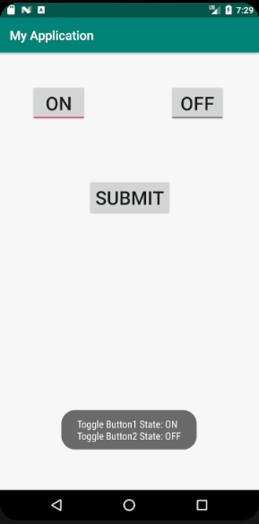

1. **Write a Program to create a toggle button to display the ON/OFF Bluetooth on the display screen.**

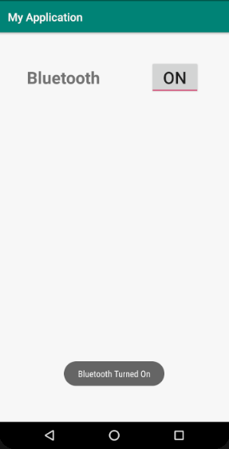

1. **Write a Program to create a 1 rounded corner image button and 1 normal image button and on the click of the button it should display which button is pressed.**

Exp 10:

1. **Write a Program to create a Login form for a social networking site.**

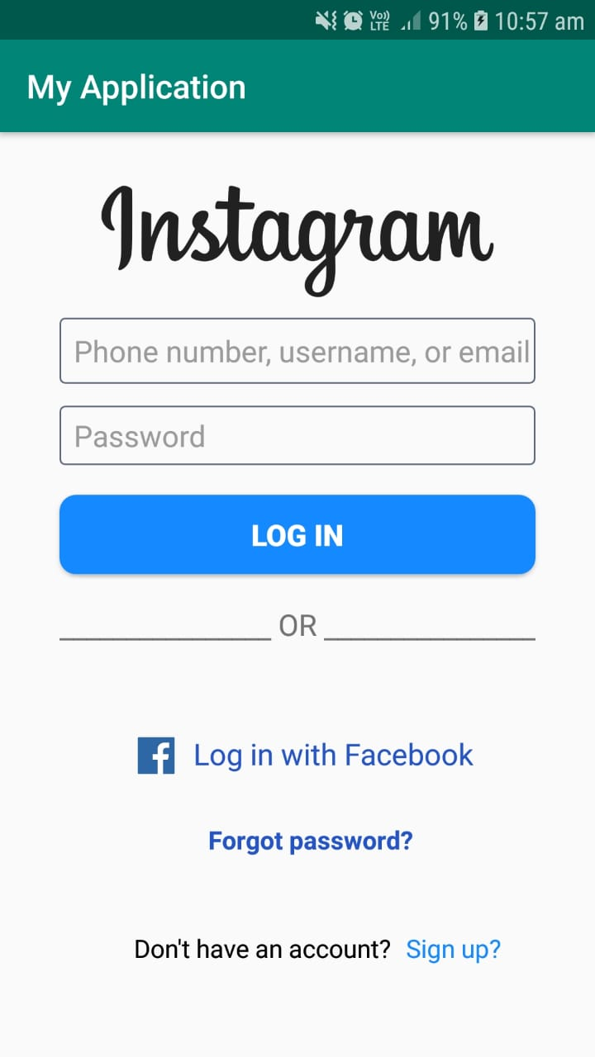

1. **Write a Program to create a Login form for student registration system.**

Exp 11:

1. **Write a Program to show five checkboxes and toast selected checkbox.**
2. **Create the below form and on the selection of checkbox it should display message as Selected, when deselected it should display message as Deselected and on button click all the selected checkbox should be displayed.**

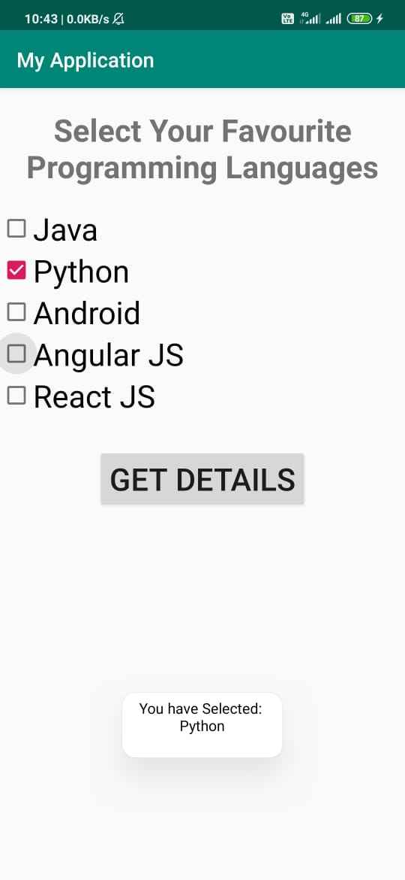

1. **Write a Program to create the below form and on the click of Ok button it should display the text of the checkbox and on Cancel button it should deselect the selected checkbox.**

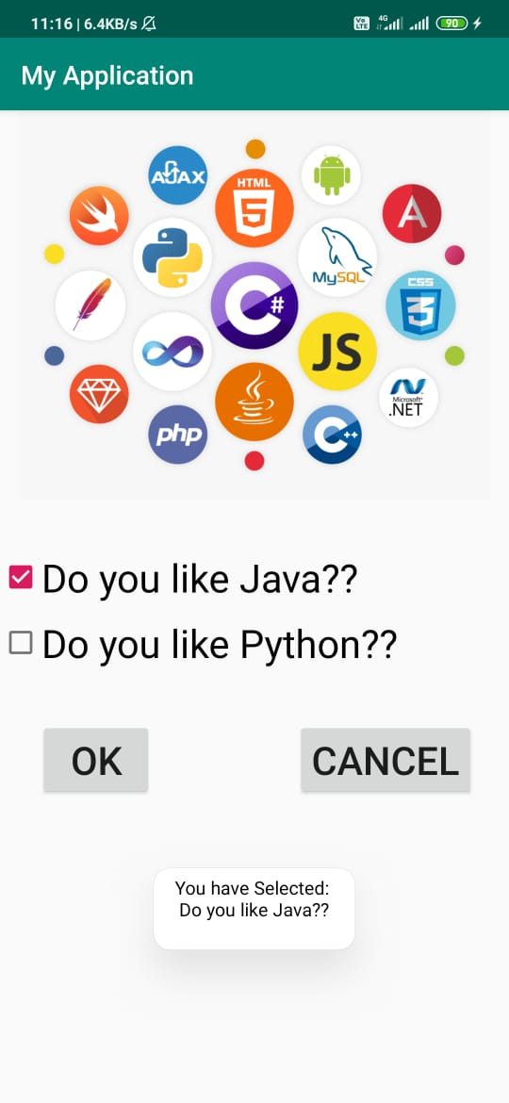

**Exp 12 :**

1. **) Write a Program to show the following output. First two radio buttons are without using radio group and next two radio buttons are using radio group. Note changes between these two. Also Toast which radio button has been selected.**

